**ReadMe:**

**Info about the code:**

1. **The code is divided into three sections: Part 1: Regularisation, Part 2: Cross Fold and part 3: Bayesian Model Selection.**
2. **In each part, the code is further divided into 4 parts according to each of the 4 data sets.**
3. **Out of these 4 parts of code, one is left uncommented and the remaining three are commented.**

**Steps to run the code:**

1. **Change the path values in the path variables according to the new location where the code will be run. The variables are divided into the base path and the respective file names of the datasets.**

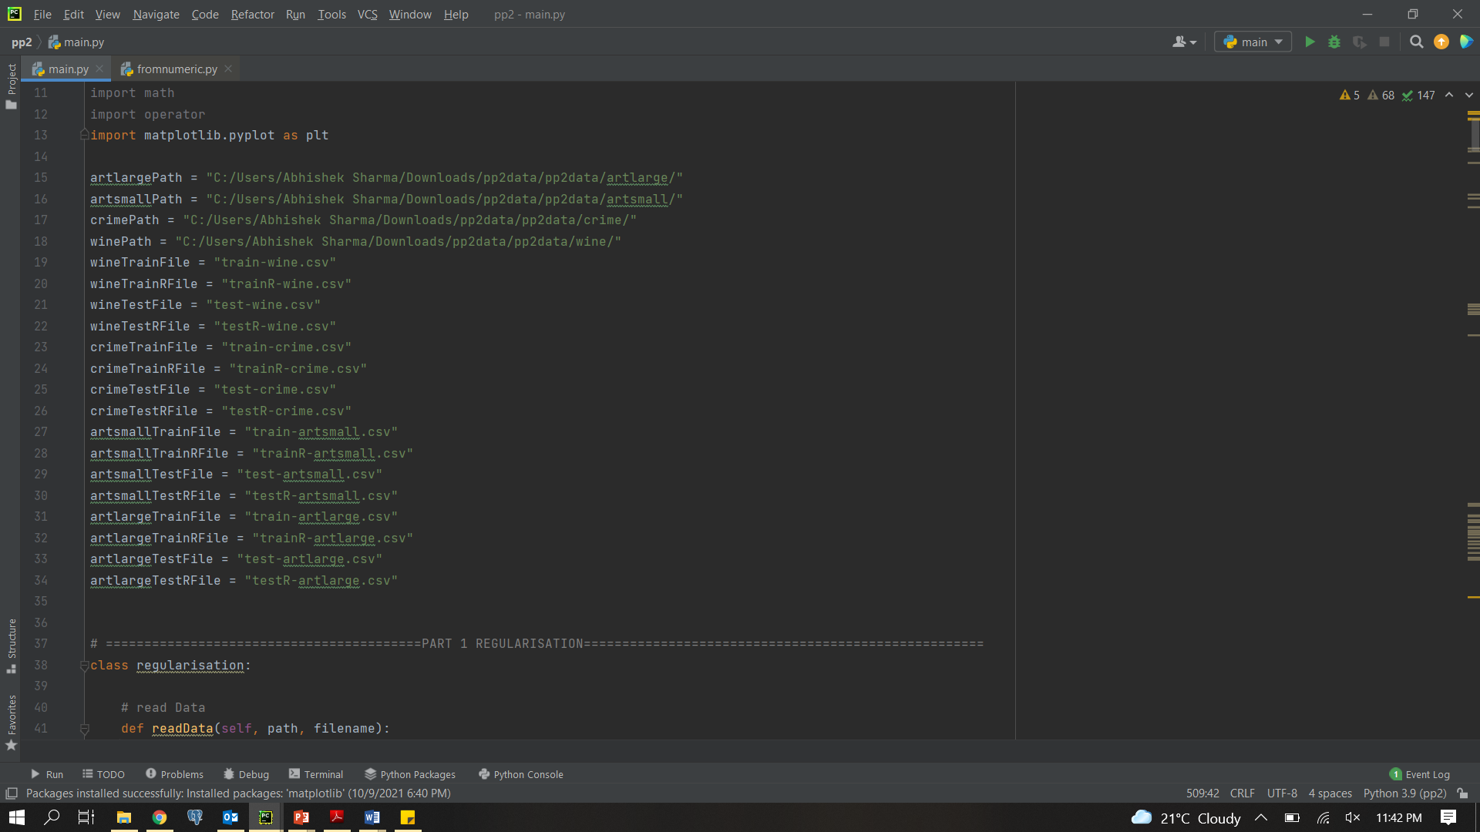

1. **Move to the part which you want to execute and uncomment the code for that particular dataset that you want to test the code on.**

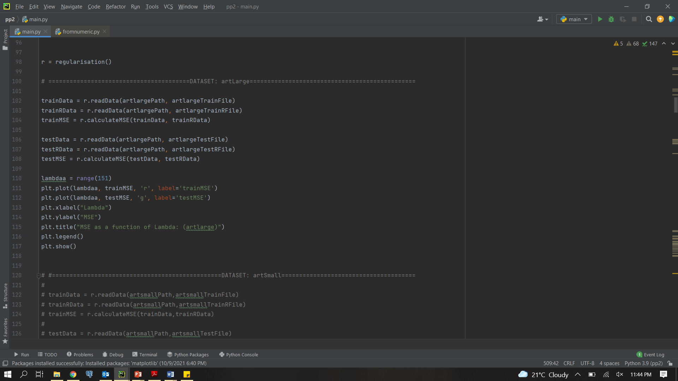

1. **Run the code.**